1.1 CROP CULTIVATION
CHAPTER 1 INTRODUCTION

From ancient period, agriculture is considered as the main and the foremost culture practiced in India. Ancient people cultivate the crops in their own land and so they have been accommodated to their needs. Therefore, the natural crops are cultivated and have been used by many creatures such as human beings, animals and birds. The greenish goods produced in the land which have been taken by the creature leads to a healthy and welfare life. Since the invention of new innovative technologies and techniques the agriculture field is slowly degrading. Due to these, abundant invention people are been concentrated on cultivating artificial products that is hybrid products where there leads to an unhealthy life. Nowadays, modern people don’t have awareness about the cultivation of the crops in a right time and at a right place. Because of these cultivating techniques the seasonal climatic conditions are also being changed against the fundamental assets like soil, water and air which lead to insecurity of food.
By analyzing all these issues and problems like weather, temperature and several factors, there is no proper solution and technologies to overcome the situation faced by us. In India there are several ways to increase the economical growth in the field of agriculture. There are multiple ways to increase and improve the crop yield and the quality of the crops. Data mining also useful for predicting the crop yield production.

1.2 DATA ANALYTIC IN AGRICULTURE
Data analytic (DA) is the process of examining data sets in order to draw conclusions about the information they contain, increasingly with the aid of specialized systems and software.[2] Earlier yield prediction was performed by considering the farmer's experience on a particular field and crop. However, as the conditions change day by day very rapidly, farmers are forced to cultivate more and more crops. Being this as the current situation, many of them don’t have enough knowledge about the new crops and are not completely aware of the benefits they get while farming them. Also, the farm productivity can be increased by understanding and forecasting crop performance in a variety of environmental conditions. Thus, the proposed system takes the location of the user as an input. From the location, the nutrients of the soil such as Nitrogen, Phosphorous,

Potassium is obtained. The processing part also take into consideration two more datasets i.e. one obtained from weather department, forecasting the weather expected in current year and the other data being static data. This static data is the crop production and data related to demands of various crops obtained from various government websites.
The proposed system applies machine learning and prediction algorithm like Multiple Linear Regression to identify the pattern among data and then process it as per input conditions. This in turn will propose the best feasible crops according to given environmental conditions. Thus, this system will only require the location of the user and it will suggest number of profitable crops providing a choice directly to the farmer about which crop to cultivate. As past year production is also taken into account, the prediction will be more accurate.
Data mining software is an analytical tool that allows users to analyze data from many different dimensions or angles, categorize, and summarize the relationships identified. Technically, data mining is the process of finding correlations or patterns among dozens of fields in large relational databases. The patterns, associations, or relationships among all this data can provide information. Information can be converted into knowledge about historical patterns and future trends. For example, summary information about crop production can help the farmers identify the crop losses and prevent it in future. Crop yield prediction is an important agricultural problem. Each and Every farmer is always tries to know, how much yield will get from his expectation. In the past, yield prediction was calculated by analyzing farmer's previous experience on a particular crop. The Agricultural yield is primarily depends on weather conditions, pests and planning of harvest operation. Accurate information about history of crop yield is an important thing for making decisions related to agricultural risk management. Therefore, this paper proposes an idea to predict the yield of the crop .The farmer will check the yield of the crop as per the acre, before cultivating onto the field.

CROP SELECTION AND CROP YIELD PREDICTION
To maximize the crop yield, selection of the appropriate crop that will be sown plays a vital role. It depends on various factors like the type of soil and its composition, climate, geography of the region, crop yield, market prices etc. Techniques like Artificial neural networks, K-nearest neighbors and Decision Trees have carved a niche for themselves in the context of crop selection which is based on various factors. Crop selection based on the effect of natural calamities like

famines has been done based on machine learning (Washington Okori, 2011). The use of artificial neural networks to choose the crops based on soil and climate has been shown by researchers (Obua, 2011). A plant nutrient management system has been proposed based on machine learning methods to meet the needs of soil, maintain its fertility levels, and hence improve the crop yield (Shivnath Ghosh, 2014). A crop selection method called CSM has been proposed which helps in crop selection based on its yield prediction and other factors (Kumar, 2009)

WEATHER FORECASTING
Indian agriculture mainly relies on seasonal rains for irrigation. Therefore, an accurate forecast of weather can reduce the enormous toil faced by farmers in India including crop selection, watering and harvesting. As the farmers have poor access to the Internet as a result of digital- divide, they have to rely on the little information available regarding weather reports. Up-to-date as well as accurate weather information is still not available as the weather changes dynamically over time. Researchers have been working on improving the accuracy of weather predictions by using a variety of algorithms. Artificial Neural networks have been adopted extensively for this purpose. Likewise, weather prediction based on machine learning technique called Support Vector Machines had been proposed (M.Shashi, 2009). These algorithms have shown better results over the conventional algorithms.

SMART IRRIGATION
Farming sector consumes a huge portion of water in India. The levels of ground water are dropping down day-by-day and global warming has resulted in climate changes. To combat the scarcity of water, many companies have come up with sensor based technology for smart farming which uses sensors to monitor the water level, nutrient content, weather forecast reports and soil temperature. EDYN Garden sensor is another example (Gupta, 2016). These smart devices are being designed on the principles of machine learning. The nutrient content of soil can also be recorded using the sensors and hence used for supplying fertilizers to the soil using smart irrigation systems. This will also reduce the labor cost in the fields, which is a huge crisis being faced by the Indian farmers these day

CHAPTER 2 LITERATURE SURVEY

TITLE: Geo-Object-Based Soil Organic Matter Mapping Using Machine Learning Algorithms With Multi-Source Geo-Spatial Data
AUTHOR : Tianjun Wu , Jiancheng Luo, Wen Dong, Yingwei Sun , Liegang Xia , and Xuejian Zhang
DESCRIPTION: Soil is a complicated historical natural continuum that presents gradual changes in its properties and geographic area. Conventional soil survey and cartography methods on a macroscopic scale based on grids with a coarse resolution are inadequate for the rapid development of precision agriculture. The demand for soil mapping content and accuracy has increased as more convenient methods of acquiring multi-source geo-spatial data have been developed, and such data are commonly employed to extract basic mapping units and environmental variables in related algorithms. We employ geo-objects as basic units of soil property mapping, which are extracted from high-resolution remote sensing images using a convolutional neural network based learning algorithm. Multi-source geo-spatial data are transferred into each geoobject as environmental variables, and the relationships between soil properties and environmental variables are mined using powerful tree-based machine learning algorithms, including regressions with random forests and XGBoost. A data set that includes soil sample points and multi-source geo-spatial data is used to evaluate the effectiveness of the proposed method. The experimental results demonstrate that the method allows for better soil organic matter mapping than state-of-the-art interpolation-based and linear-regression-based methods. The proposed procedure has potential to be a general method for mapping other soil properties. Its advantages are embodied in the modeling of relatively miscellaneous data with implicitly associated non-linear relationships between soil properties and environmental variables. The spatial scale and accuracy of the finer maps capture more detailed characteristics of the soil properties and are applicable to the micro-domain fields required for refined soil mapping with small variations.

TITLE: IoT based Smart Soil Monitoring System for Agricultural Production AUTHOR: Dr.N.ANANTHI, M.E, Ph.D Divya J. Divya M. Janani V
DESCRIPTION: Agriculture plays the major role in economics and survival of people in India. The purpose of this project is to provide embedded based system for soil monitoring and irrigation

to reduce the manual monitoring of the field and get the information via mobile application. The system is proposed to help the farmers to increase the agricultural production. The soil is tested using various sensors such as pH sensor, temperature sensor, and humidity sensor. Based on the result, the farmers can cultivate the appropriate crop that suits the soil. The obtained sensor values are sent to the field manager through the Wi-Fi router and the crop suggestion is made through the mobile application. Automatic irrigation system is carried out when the soil temperature is high. Crop image is captured and it is sent to the field manager to suggest pesticides.

TITLE: An Intelligent System for Predicting Thrips Tabaci Linde Pest Population Dynamics Allied To Cotton Crop
AUTHOR: Jyothi patil Dr A.Govardhan Dr V.D.Mytri DESCRIPTION:
The agricultural sector in India is up against a series of problems when it comes to increasing crop productivity. A number of successful researches have been carried out to discover productive agricultural practices to improve crop cultivation but despite their efforts, productivity achieved by most of the farmers has not been in upper-bound level. The prime reason stated globally for crop loss is Insect pests. An efficient pest management technique can be devised if we could predict in advance the occurrences of peak activities of a given pest. Researchers are undertaken to understand the pest population dynamics by employing analytical and other techniques on pest surveillance data sets. In this paper, we present an intelligent system for pest prediction in cotton crop with the aid of the data obtained from College of Agriculture, Raichur, India. We make an effort to understand population dynamics of Thrips tabaci Linde (Thrips) pest on cotton (Gossypium Arboreum) crop using neural networks by analyzing pest surveillance data. The Multi-layer perceptron neural network with back-propagation training algorithm is utilized in the design of the presented intelligent system. The results show that neural network system can be able to give results with a very high degree of accuracy and is best suited to build a prediction system. With the aid of this pest prediction system, the farming communities get more beneficiaries in crop productivity.
  - TITLE: Improving Crop Productivity Through A Crop Recommendation System Using Ensembling Technique
AUTHOR: Nidhi H Kulkarni Dr. G N Srinivasan Dr. B M Sagar Dr.N K Cauvery

DECSRIPTION:

- Agriculture plays a predominant role in the economic growth and development of the country. The major and serious setback in the crop productivity is that the farmers do not choose the right crop for cultivation. In order to improve the crop productivity, a crop recommendation system is to be developed that uses the ensembling technique of machine learning. The ensembling technique is used to build a model that combines the predictions of multiple machine learning models together to recommend the right crop based on the soil specific type and characteristics with high accuracy. The independent base learners used in the ensemble model are Random Forest, Naive Bayes, and Linear SVM. Each classifier provides its own set of class labels with an acceptable accuracy. The class labels of individual base learners are combined using the majority voting technique. The crop recommendation system classifies the input soil dataset into the recommendable crop type, Kharif and Rabi. The dataset comprises of the soil specific physical and chemical characteristics in addition to the climatic conditions such as average rainfall and the surface temperature samples. The average classification accuracy obtained by combining the independent base learners is 99.91%.
  - TITLE: An Effective Method of Controlling the Greenhouse and Crop Monitoring UsingGSM
AUTHOR: P. S. Asolkar Prof.Dr. U. S. Bhadade

DESCRIPTION:
the advent of green house technology has become most important and most widely used part in daily life because green house environment protects plants from undesirable environmental conditions and provides well desired conditions for growing under controlled atmosphere. The main aim of this paper is to propose effective method for crop monitoring in agricultural which shows the path to rural farming community to replace traditional crop cultivation techniques. The green houses are precisely used for improvement in productivity, quality, quantity and profitability of vegetable, flower and fruit crops. In this paper, green house approach has been presented supporting GSM wireless technology. The proposed green house system provides impact on varieties of crop species mostly flowers, vegetable crops and fruit crops. The presented system effectively monitors and controls the green house parameters of crucial importance like temperature, humidity, soil moisture, and light intensity and Co2 gas. The system had been tested in green house environment and observations had been recorded for crop analysis purpose. The crop analysis helps farmers for monthly future prediction to know the expenditure for growing crop. This makes effective solution for farmers to grow highly efficient and disease free crop

  - TITLE: Agricultural Production Output Prediction Using Supervised Machine Learning Techniques
AUTHOR: Md. Tahmid Shakoor, Karishma Rahman, Sumaiya Nasrin Rayta, Amitabha Chakrabarty

DESCRIPTION:
Farmers usually plan the cultivation process based on their previous experiences. Due to the lack of precise knowledge about cultivation, they end up cultivating undesirable crops. To help the farmers take decisions that can make their farming more efficient and profitable, the research tries to establish an intelligent information prediction analysis on farming in Bangladesh. However, this way of farming here is still at the initial stage. The research suggests area based beneficial crop rank before the cultivation process. It indicates the crops that are cost effective for cultivation for a particular area of land. To achieve these results, we are considering six major crops which are Aus rice, Aman rice, Boro rice, Potato, Jute and Wheat. The prediction is based on analyzing a static set of data using Supervised Machine Learning techniques. This static dataset contains previous years’ data taken from the Yearbook of Agricultural Statistics and Bangladesh Agricultural Research Council of those crops according to the area. The research has an intent to use Decision Tree Learning- ID3 (Iterative Dichotomiser 3) and K-Nearest Neighbors Regression algorithms.
  - TITLE: Investigating the capability of multi-temporal Landsat images for crop identification in high farmland fragmentation regions
AUTHOR: Zhang Miao1, 2, Li Qiangzi1 , Wu Bingfang1,*

DESCRIPTION:
Crop identification is a critical component for grain production prediction. Identifying crop type using remote sensing techniques has been investigated for many decades. A number of different supervised methods have been developed to discriminate different crops. However, most of these methods were applied to areas with relatively large cultivated fields. In China, the cultivation policy leads to extreme complexity in the agricultural landscape, especially in summer and autumn seasons. The objective of this study was to investigate the capability of multi-temporal Landsat images for crop identification in a region with high farmland fragmentation. The study area is located in Taigu, Shanxi province, where the crop planting structure is very complicated. A total of 7 Landsat Enhanced Thematic Mapper Plus (ETM+) images were acquired from 14 October

2003 to 26 June 2004 for classification. Two most favorable classifiers, support vector machine (SVM) and maximum likelihood classifier (MLC) were selected for classification with training samples using different combinations of multi-temporal Landsat images. The overall classification accuracy and Kappa statistics estimated from the confusion matrix using validation samples were selected for evaluating all classification results. Accuracy assessment results indicated that multi- temporal ETM+ data achieved satisfactory classification accuracy (best overall accuracy 89.61%) in the study area. SVM classifier performed better than MLC when three or less Landsat images were used. The addition of the temporal dimension further increased the overall classification accuracy for both SVM and MLC, but the accuracy increased slightly for SVM classifier. The time of data acquisitions are of great importance for crop classification. Results in this paper indicated that multitemporal Landsat ETM+ data are capable for crop discrimination in regions with high farmland fragmentation. In the future, the use of China Environment Satellite HJ1A/B data for this application should be investigated in the future for the higher temporal resolution and greater spatial coverage.
  - TITLE: Comparison of Statistical Methods for Predicting Wheat Yield Trends in Turkey
AUTHOR: D. Turgay Altılar Anıl Suat Terliksiz

DESCRIPTION:
Population of the world is constantly increasing and it is necessary to have sufficient crop production. Monitoring crop growth and yield prediction are very important for the economic development of a nation. The prediction of crop yield have direct impact on national and international economies and play important role in the food management and food security. Crop growth and yield are affected by various factors such as genetic potential of crop cultivar, soil, weather, cultivation practices (date of sowing, amount of irrigation and fertilizer, etc.) and biotic stress. Thus crop yield modelling is a complex and difficult task. Several methods of crop yield estimation have been developed such as statistical, agro-meteorological, empirical, biophysical, mechanistic, etc. Most of the studies on yield trend prediction is based on statistical methods. Yield time series obtained from national agencies are used in order to predict future yield trends. There are different types of statistical methods used for predicting yield trends such as simple linear regression, quadratic regression, cubic regression, exponential regression, single exponential smoothing, etc. Most of the studies are only dealing with past years and yield at these years. Factors such as crop type, soil properties, weather conditions, and irrigation and cultivation practices affect

crop growth and yield. Consequently crop yield modelling needs too many parameters that make it a complex and difficult task. Unfortunately, only a small portion of these factors is known with certainty. For example weather is a very large determinant of yields but remains very unpredictable. Some of these factors (average temperature in a year, etc.) can also be included in some measure to these methods, which means having more than one independent variable in trend prediction equations. The purpose of this study is to evaluate performance of these statistical methods and to determine which of these methods performs better for predicting wheat yield trends in Turkey. Once methods which perform better than others are determined, other influencing factors and adding these factors to the prediction equations can be studied as a future work.

TITLE: Agricultural Activity Recognition with Smart-shirt and Crop Protocol AUTHOR: Sanat Sarangi, Somya Sharma, Bhushan Jagyasi
DESCRIPTION:
Accurate recognition of agricultural activity has a direct bearing on improving farm productivity in terms of achieving crop yield improvements, imparting precision training to farmers wherever needed, and measuring their efforts. Moreover, farm activities are not independent of each other. Cultivation of any crop is associated with a defined pattern of farmer activities called the crop protocol. With an indigenously developed garment for the farmer called smart-shirt, we propose a model for activity classification which has a mean activity prediction accuracy of over 88% for seven classes. The performance of numerous classifiers–SVM, Naive Byes, K-NN, LDA and QDA–is rigorously evaluated and compared for activity prediction. We also propose a model to use the a priori information associated with the crop protocol to recognize the major activity when presented with an unclear evidence of reported activities.

TITLE: Weather Analysis to Predict Rice Cultivation Time Using Multiple Linear
Regression to Escalate Farmer’s Exchange Rate AUTHOR: Luminto Harlili, M DESCRIPTION:
Agriculture is one of primary sectors of the national economy and is receiving more attention from government annually in order to increase productions and boost national economy. Agriculture, especially rice cultivation, has been challenged with various issues for the past decades such as extreme weather (global warming) which could result in crop failure. From the weather aspect, this paper aims to build weather analysis program to predict rice cultivation time in hope to escalate

Farmer’s Exchange Rate (FER) . Farmer’s Exchange Rate is an proxy indicator to determine how prosperous farmers from certain regions are. Weather analysis is conducted by retrieving weather data from National Weather Forecast and Farmer’s Exchange Rate data from National Statistics Authority for the past 1 year and using the obtained data to build a regression model using Multiple Linear Regreesion (MLR) to determine the correlation between weather and FER. The variables are “Average Temperature”, “Average Humidity”, “Rainfall”, and “Solar Radiation”. The resulted model is then projected using line chart. Based on evaluation the proposed analysis from 2 different regions tested gives overall Root Mean Square Error (RMSE) between 0.39 – 1.34.

TITLE: High Granularity Remote Sensing and Crop Production over Space and Time: NDVI over the Growing Season and Prediction of Cotton Yields at the Farm Field Level in Texas
AUTHOR: Bert Little Michael Schucking Kenton Ross DESCRIPTION:
Remote sensing has been applied to agriculture at very coarse levels of granularity (i.e., national levels) but few investigations have focused on yield prediction at the farm unit level. Specific aims of the present investigation are to analyze the ability of Moderate Resolution Imaging Spectroradiometer (MODIS) data to predict cotton yields in two highly homogeneous counties in west Texas. In one study county > 90% of cotton grown is irrigated, while the other study county 40 miles south has > 85% non-irrigated cotton. Regression analysis by day from April to November at the county and farm levels reveals a highly significant ability for MODIS to predict cotton yields. R2 values ranged from 0.90 to 0.98 for irrigated cotton and 0.80 to .90 for non- irrigated cotton practices. The objective in future studies is to algorithmically extend these analyses to the ~ 300 million acres of arable land under cultivation in the United States.

CHAPTER 3
EXISTING AND PROPOSED SYSTEM

EXISTING SYSTEM
Soil is a complicated historical natural continuum that presents gradual changes in its properties and geographic area. Conventional soil survey and cartography methods on a macroscopic scale based on grids with a coarse resolution are inadequate for the rapid development of precision agriculture. The demand for soil mapping content and accuracy has increased as more convenient methods of acquiring multi-source geo-spatial data have been developed, and such data are commonly employed to extract basic mapping units and environmental variables in related algorithms. We employ geo-objects as basic units of soil property mapping, which are extracted from high-resolution remote sensing images using a convolution neural network based learning algorithm. Multi-source geo-spatial data are transferred into each geo object as environmental variables, and the relationships between soil properties and environmental variables are mined using powerful tree-based machine learning algorithms, including regressions with random forests and XGBoost. A data set that includes soil sample points and multi-source geo-spatial data is used to evaluate the effectiveness of the proposed method. The experimental results demonstrate that the method allows for better soil organic matter mapping than state-of-the-art interpolation-based and linear-regression-based methods. The proposed procedure has potential to be a general method for mapping other soil properties. Its advantages are embodied in the modeling of relatively miscellaneous data with implicitly associated non-linear relationships between soil properties and environmental variables. The spatial scale and accuracy of the finer maps capture more detailed characteristics of the soil properties and are applicable to the micro-domain fields required for refined soil mapping with small variations.

EXISTING SYSTEM ARCHITECTURE
In the framework of our methodology, geo-objects with geographic meaning of edges are the smallest spatial unit of mapping. In this paper, it is referred as the smallest geographical entity (image-object) that can be perceived with exact shape boundary and determined by clear land cover type under the constraint of certain spatial scale (image resolution). Clear edge and homogeneous internal characteristics are two fundamental characteristics of these meaningful geo- objects with geographic edges. That is, geo-objects, the basic mapping units in our study, are controlled by the image edges, which are always extracted by segmentation methods on high- resolution remote sensing images and are in line with visual format of image-objects reflecting the

exact geographic entries. Although unsupervised edge- or region-based segmentation methods had been commonly used to extract image-objects from satellite images, the segmented objects often have problems of over-segmentation or under-segmentation. They are not consistent with the real environment and cannot meet the requirements from the perspectives of visual interpretation. Recently, supervised segmentation methods using object-edge samples had been shown effective to extract image-objects’ edges. Prior knowledge in the edge samples from artificial visual interpretation will be learned in these supervised methods, which makes their segmentation results more consistent with visual interpretation and the phenomenon of over-segmentation or under segmentation will be avoided to some extent. This supervised strategy has been successfully applied in many fields such as natural image semantics segmentation. Here, we introduce it into the similar processing task for satellite image segmentation.
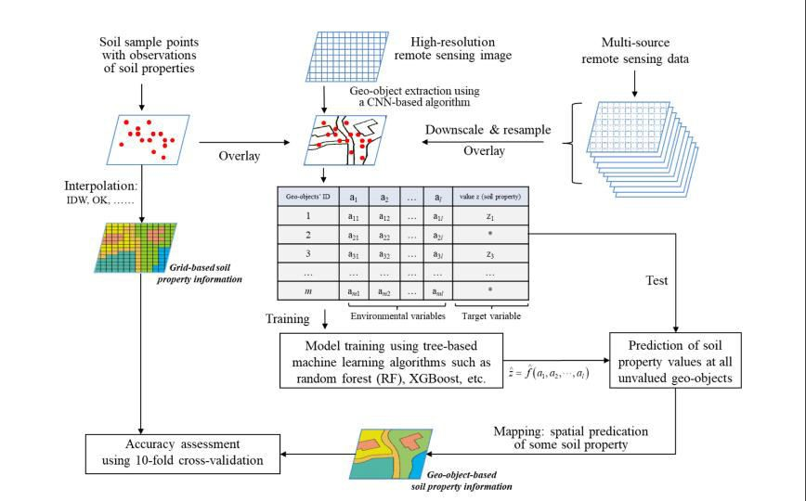
Fig.3.1 Existing System Architecture

DISADVANTAGE
    - Result prediction is made from sample images thus the result may vary
    - Need large amount of Geo- spatial data SAR images

    - Sample point data quality and quantity is not known since the prediction is made from images.

PROPOSED SYSTEM
The system aims to help farmers to cultivate proper crop for better yield production. To be precise and accurate in predicting crops, the project analyze the nutrients present in the soil and the crop productivity based on embedded sensors with the microcontrollers added in it. It can be achieved using supervised learning algorithm random forest method and linear regression algorithm. It compares the accuracy obtained by different network learning techniques and the most accurate result will be delivered to the end user. Along with this, the end user is provided with proper recommendations about fertilizers suitable for every particular crop. After the soil nutrient prediction the type of crop cultivation, vegetative index, pest, soil matters, pest and the disease attack can be predicted easily using the techniques. The proposed system will check soil quality and predict the cop yield accordingly along with it provide fertilizer recommendation if needed depending upon the quality of soil. Thus the system will help reduce the difficulties faced by the farmers and stop them from attempting suicides. It will act as a medium to provide the farmers efficient information required to get high yield and thus maximize profits which in turn will reduce the suicide rates and lessen his difficulties.

PROPOSED SYSTEM ARCHITECTURE

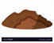
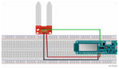

Soil test hardware

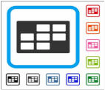
Soil
Crop prediction
Machine learning classifier
(Extracted soil data
set from soil)


Dynamic data set

Fig.3.2 Proposed System Architecture

ADVANTAGES
- The soil nutrients and the minerals can be predicted using linear regression
- The crop cultivation according to the soil is suggested by machine learning
- The accuracy of prediction is high
- Reduce the stress of farmers and consumers

CHAPTER 4 SYSTEM REQUIREMENTS

HARDWARE REQUIREMENTS
    - Processor : Dual core processor 2.6.0 GHz
    - RAM : 1GB
    - Hard disk : 160 GB
    - Compact Disk : 650 MB
    - Keyboard : Standard keyboard
    - Monitor : 15 inch color monitor

SOFTWARE REQUIREMENTS
    - Front End : PYTHON
    - IDE : pycharm
    - Platform : Windows 7

DESCRIPTION
Python is an interpreted, object-oriented, high-level programming language with dynamic semantics. Its high-level built in data structures, combined with dynamic typing and dynamic binding, make it very attractive for Rapid Application Development, as well as for use as a scripting or glue language to connect existing components together. Python's simple, easy to learn syntax emphasizes readability and therefore reduces the cost of program maintenance. Python supports modules and packages, which encourages program modularity and code reuse. The Python interpreter and the extensive standard library are available in source or binary form without charge for all major platforms, and can be freely distributed.
Often, programmers fall in love with Python because of the increased productivity it provides. Since there is no compilation step, the edit-test-debug cycle is incredibly fast. Debugging Python programs is easy: a bug or bad input will never cause a segmentation fault. Instead, when the interpreter discovers an error, it raises an exception. When the program doesn't catch the exception, the interpreter prints a stack trace. A source level debugger allows inspection of local and global variables, evaluation of arbitrary expressions, setting breakpoints, stepping through the

code a line at a time, and so on. The debugger is written in Python itself, testifying to Python's introspective power. On the other hand, often the quickest way to debug a program is to add a few print statements to the source: the fast edit-test-debug cycle makes this simple approach very effective.

4.1.1 FEATURES IN PYTHON
There are many features in Python, some of which are discussed below –
- Easy to code:
Python is high level programming language. Python is very easy to learn language as compared to other language like c, c#, java script, java etc.It is very easy to code in python language and anybody can learn python basic in few hours or days.It is also developer-friendly language.
- Free and Open Source:
Python language is freely available at official website and you can download it from the given download link below click on the Download Python keyword.
Download Python
Since, it is open-source; this means that source code is also available to the public. So you can download it as, use it as well as share it.
- Object-Oriented Language:
One of the key features of python is Object-Oriented programming. Python supports object oriented language and concepts of classes, objects encapsulation etc.
- GUI Programming Support:
Graphical Users interfaces can be made using a module such as PyQt5, PyQt4, wxPython or Tk in python.
PyQt5 is the most popular option for creating graphical apps with Python.
- High-Level Language:
Python is a high-level language. When we write programs in python, we do not need to remember the system architecture, nor do we need to manage the memory.
- Extensible feature:
Python is a Extensible language. we can write our some python code into c or c++ language and also we can compile that code in c/c++ language.
- Python is Portable language:

Python language is also a portable language. for example, if we have python code for windows and if we want to run this code on other platform such as Linux, Unix and Mac then we do not need to change it, we can run this code on any platform.
- Python is integrated language:
Python is also an integrated language because we can easily integrated python with other language like c, c++ etc.
- Interpreted Language:
Python is an Interpreted Language. because python code is executed line by line at a time. like other language c, c++, java etc there is no need to compile python code this makes it easier to debug our code.The source code of python is converted into an immediate form called bytecode.
- Large Standard Library
Python has a large standard library which provides rich set of module and functions so you do not have to write your own code for every single thing.There are many libraries present in python for such as regular expressions, unit-testing, web browsers etc.
- Dynamically Typed Language:
Python is dynamically-typed language. That means the type (for example- int, double, long etc) for a variable is decided at run time not in advance.because of this feature we don’t need to specify the type of variable.
Machine Learning is the hottest trend in modern times. According to Forbes, Machine learning patents grew at a 34% rate between 2013 and 2017 and this is only set to increase in the future. And Python is the primary programming language used for much of the research and development in Machine Learning. Python is currently the most popular programming language for research and development in Machine Learning. But you don’t need to take my word for it! According to Google Trends, the interest in Python for Machine Learning has spiked to an all-new high with other ML languages such as R, Java, Scala, Julia, etc. lagging far behind.

CHAPTER 5 MODULE DESCRIPTION

5.1 SOIL TESTING
Soil is a vital component in any ecosystem, in fact, our very existence depend on the 6-12 inches underneath our feet. The properties of soil are mainly classified into three groups physical, chemical and electrical. The soil fertility is tested using the three factors temperature, humidity and moisture contents of the soil the farming field is analyzed by three different parameters. First, the water content of the soil is measured. This serves as a key value in operating the motor. Measuring the water quantity is done using soil moisture sensor. Crop forecasting relies on computer programs that describe the plant-environment interactions in quantitative terms. The soil testing program starts with the collection of a soil sample from a field. The first basic principle of soil testing is that a field can be sampled in such a way that chemical analysis of the soil sample will accurately reflect the field’s true nutrient status. The purpose of soil testing in high-yield farming is to determine the relative ability of a soil to supply crop nutrients during a particular growing season, to determine the needs, and for diagnosing problems such as excessive salinity. A soil test is the analysis of a soil sample to determine nutrient content, composition and other characteristics. Tests are usually performed to measure fertility and indicate deficiencies that need to be remedied[4].Soil fertility is a crucial attribute which is considered for land evaluation, also achieving and maintaining necessary levels of fertility is important for nurturing crop production, hence this paper includes steps for building an efficient and accurate predictive model of soil fertility with the help of data mining techniques. The overall goal of the data mining process is to extract information from a data set and transform it into an understandable structure for further use.

SOIL DATA COLLECTION
Dataset Collection the dataset is part of surveys which are collected from the agriculture university, Coimbatore district. Primary data for the soil survey are acquired by field sampling. These samples are then sent for chemical and physical analysis at the soil testing laboratories; hence this dataset was collected from the agriculture university.. The data in the sensor residing in Arduino will be transmitted through a dedicated channel to next phase. The sensors read the gathered data from the field continuously and send it to Arduino which has a separate port for reading sensor analog data ensuring the correctness of data. The collected data from Arduino is sent for processing through th RF24L01 transceiver. In this phase, the transceiver will act as a transmitter, capable of sending and receiving data over 1km. The field is analyzed continually and data is transmitted with a time period of 1 second. All the data read by Arduino is sent and stored in data set.
Data mining techniques are mainly divided in two groups, classification and clustering techniques [8]. Classification techniques are designed for classifying unknown samples using information provided by a set of classified samples. This set is usually referred to as a training set as it is used to train the classification technique how to perform its classification. This work

presents a system, which uses data mining techniques in order to predict the category of the analyzed soil datasets. The category, thus predicted will indicate the yielding of crops.

DATA SET PRE PROCESSING
Data preprocessing is a data mining technique that involves transforming raw data into an understandable format. Real-world data is often incomplete, inconsistent, and/or lacking in certain behaviors or trends, and is likely to contain many errors. Data preprocessing is a proven method of resolving such issues. In Real world data are generally incomplete: lacking attribute values, lacking certain attributes of interest, or containing only aggregate data. Noisy: containing errors or outliers. Inconsistent: containing discrepancies in codes or names.

Steps in Data Preprocessing

Step 1: Import the libraries
Step 2: Import the data-set
Step 3: Check out the missing values
Step 4: See the Categorical Values
Step 5: Splitting the data-set into Training and Test Set
Step 6: Feature Scaling

In general, learning algorithms benefit from standardization of the data set. If some outliers are present in the set, robust scalars or transformers are more appropriate. The behaviors of the different scalers, transformers, and normalizers on a dataset containing marginal outliers are highlighted in Compare the effect of different scalars on data with outliers. Pre-processing refers to the transformations applied to our data before feeding it to the algorithm. Data Preprocessing is a technique that is used to convert the raw data into a clean data set. In other words, whenever the data is gathered from different sources it is collected in raw format which is not feasible for the analysis.

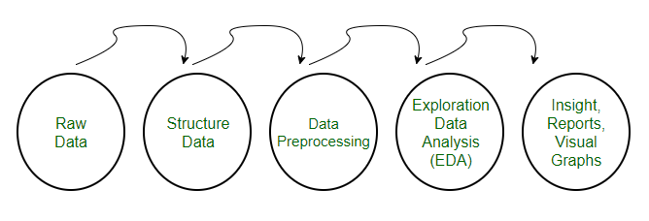
Fig 5.3 Raw data analysis and exploration steps

Need of Data Preprocessing
      - For achieving better results from the applied model in Machine Learning projects the format of the data has to be in a proper manner. Some specified Machine Learning model needs information in a specified format, for example, Linear regression does not support null values; therefore to execute Linear regression algorithm null values have to be managed from the original raw data set.
      - Another aspect is that data set should be formatted in such a way that more than one Machine Learning and Deep Learning algorithms are executed in one data set, and best out of them is chosen.

REGRESSION CLASSIFIER
Linear Regression is a machine learning algorithm based on supervised learning. Linear regression performs the task to predict a dependent variable value (y) based on a given independent variable (x). So, this regression technique finds out a linear relationship between x (input) and y(output).
While training the model we are given :
x: input training data (univariateone input variable(parameter))
y: labels to data (supervised learning)
When training the model – it fits the best line to predict the value of y for a given value of x. The
model gets the best regression fit line by finding the best θ1 and θ2 values.
θ1: intercept
θ2: coefficient of x

Once we find the best θ1 and θ2 values, we get the best fit line. So when we are finally using our model for prediction, it will predict the value of y for the input value of x.

Cost Function (J):
By achieving the best-fit regression line, the model aims to predict y value such that the error difference between predicted value and true value is minimum. So, it is very important to update the θ1 and θ2 values, to reach the best value that minimize the error between predicted y value (pred) and true y value (y).

Gradient Descent:
To update θ1 and θ2 values in order to reduce Cost function (minimizing RMSE value) and achieving the best fit line the model uses Gradient Descent. The idea is to start with random θ1 and θ2 values and then iteratively updating the values, reaching minimum cost.
Regression analysis is primarily used for two conceptually distinct purposes. First, regression analysis is widely used for prediction and forecasting, where its use has substantial overlap with the field of machine learning. Second, in some situations regression analysis can be used to infer causal relationships between the independent and dependent variables. Importantly, regressions by themselves only reveal relationships between a dependent variable and a collection of independent variables in a fixed dataset. To use regressions for prediction or to infer causal relationships, respectively, a researcher must carefully justify why existing relationships have predictive power for a new context or why a relationship between two variables has a causal interpretation. The latter is especially important when a researcher hopes to estimate causal relationships using observational data. he relationship between dependent variable is given by straight line and it has only one independent variable.

Y = α + Β X (2)
Model 'Y', is a linear function of 'X'. The value of 'Y' increases or decreases in linear manner according to which the value of 'X' also changes.

PATTERN PREDICTION
A prediction model is trained with a set of training sequences. Once trained, the model is used to perform sequence predictions. A prediction consists in predicting the next items of a sequence. Learning of sequential data continues to be a fundamental task and a challenge in pattern recognition and machine learning. Sequence prediction is different from other types of supervised learning problems. The sequence imposes an order on the observations that must be preserved when training models and making predictions. Generally, prediction problems that involve sequence data are referred to as sequence prediction problems; although there are a suite of problems that differ based on the input and output sequences. Pattern recognition is the process of recognizing patterns by using a Machine Learning algorithm. Pattern recognition can be defined as the classification of data based on knowledge already gained or on statistical information extracted from patterns and/or their representation. Pattern recognition is the ability to detect arrangements of characteristics or data that yield information about a given system or data set. Predictive analytics in data science work can make use of pattern recognition algorithms to isolate statistically probable movements of time series data into the future. In a technological context, a pattern might be recurring sequences of data over time that can be used to predict trends, particular configurations of features in images that identify objects, frequent combinations of words and phrases for natural language processing (NLP), or particular clusters of behaviour on a network that could indicate an attack — among almost endless other possibilities. In IT, pattern recognition is a branch of Machine Learning that emphasizes the recognition of data patterns or data regularities in a given scenario. Pattern recognition involves classification and cluster of patterns.

5.5.1 Training and Learning Models in Pattern Recognition

Training and Learning is the building block model of Pattern Recognition. Learning is a phenomena through which a system gets trained and becomes adaptable to give result in an accurate manner. Learning is the most important phase as how well the system performs on the data provided to the system depends on which algorithms used on the data.

The model need to undergo from two phases and dataset is divided into two categories, one which is used in training the model and called as Training set and the other is used in testing the model after training called as Testing set.

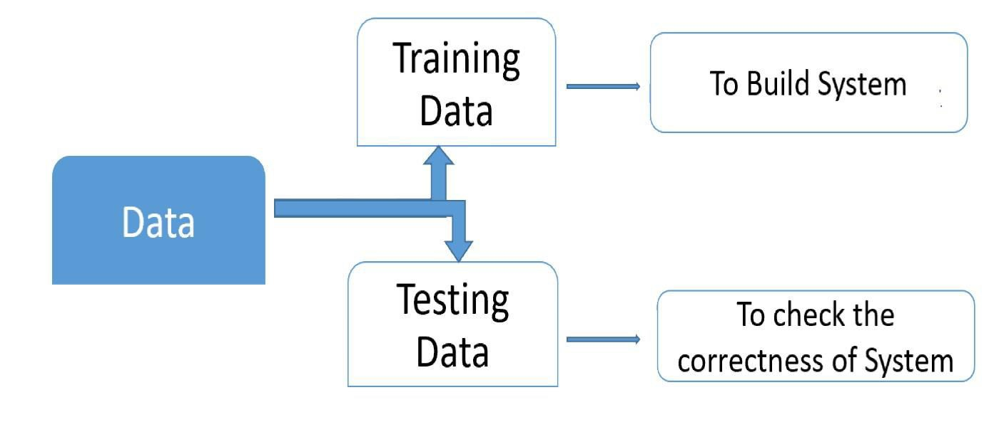

Fig 5.5 Data Training and testing with the pattern based recognition

Training set

Training set is used to build a model. It consists of the set of images which are used to train the system. Training rules and algorithms used give relevant information on how to associate input data with output decision. The system is trained by applying these algorithms on the dataset, all the relevant information is extracted from the data and results are obtained. Generally, 80-85% of the data of the dataset is taken for training data.

Testing set

Testing data is used to test the system. It is the set of data which is used to verify whether the system is producing the correct output after being trained or not. Generally, 20% of the data of the dataset is used for testing. Testing data is used to measure the accuracy of the system. Thus the prediction of the soil yield can be identified using the implemented pattern recognition

CHAPTER 6
SYSTEM IMPLEMENTATION, TESTING AND MAINTANANCE

IMPLEMENTATION
Systems implementation is the process of: defining how the information system should be built (i.e., physical system design), ensuring that the information system is operational and used, ensuring that the information system meets quality standard (i.e., quality assurance).
Systems implementation is the process of:
    - Defining how the information system should be built (i.e., physical system design),
    - Ensuring that the information system is operational and used,
    - Ensuring that the information system meets quality standard (i.e., quality assurance).

6.1.1 SYSTEMS DESIGN
Conceptual design – what the system should do
Logical design – what the system should look to the user Physical design – how the system should be built
A product software implementation method is a systematically structured approach to effectively integrate a software based service or component into the workflow of an organizational structure or an individual end-user.
Implementation is the carrying out, execution, or practice of a plan, a method, or any design, idea, model, specification, standard or policy for doing something. As such, implementation is the action that must follow any preliminary thinking in order for something to actually happen.

Activities of the Process
The following major activities and tasks are performed during this process:
Define the implementation strategy - Implementation process activities begin with detailed design and include developing an implementation strategy that defines fabrication and coding procedures, tools and equipment to be used, implementation tolerances, and the means and criteria for auditing configuration of resulting elements to the detailed design documentation. In the case of repeated system element implementations (such as for mass manufacturing or replacement elements), the implementation strategy is defined and refined to achieve consistent and repeatable element production; it is retained in the project decision database for future use. The implementation strategy contains the arrangements for packing, storing, and supplying the implemented element.

Realize the system element - Realize or adapt and produce the concerned system element using the implementation strategy items as defined above. Realization or adaptation is conducted with regard to standards that govern applicable safety, security, privacy, and environmental guidelines or legislation and the practices of the relevant implementation technology. This requires the fabrication of hardware elements, development of software elements, definition of training capabilities, drafting of training documentation, and the training of initial operators and maintainers.
Provide evidence of compliance - Record evidence that the system element meets its requirements and the associated verification and validation criteria as well as the legislation policy. This requires the conduction of peer reviews and unit testing, as well as inspection of operation and maintenance manuals. Acquire measured properties that characterize the implemented element (weight, capacities, effectiveness, level of performance, reliability, availability, etc.).
Package, store, and supply the implemented element - This should be defined in the implementation strategy.

6.2 SYSTEM TESTING
Testing is a series of different tests that whose primary purpose is to fully exercise the computer based system. Although each test has a different purpose, all work should verify that all system element have been properly integrated and performed allocated function. Testing is the process of checking whether the developed system works according to the actual requirement and objectives of the system. The philosophy behind testing is to find the errors. A good test is one that has a high probability of finding an undiscovered error. A successful test is one that uncovers the undiscovered error. Test cases are devised with this purpose in mind. A test case is a set of data that the system will process as an input.

6.2.1 TYPES OF TESTS

UNIT TESTING
The first test in the development process is the unit test. The source code is normally divided into modules, which in turn are divided into smaller units called units. These units have specific behavior. The test done on these units of code is called unit test. Unit test depends upon the language on which the project is developed. Unit tests ensure that each unique path of the

project performs accurately to the documented specifications and contains clearly defined inputs and expected results. Functional and reliability testing in an Engineering environment. Producing tests for the behavior of components (nodes and vertices) of a product to ensure their correct behavior prior to system integration.

INTEGRATION TESTING

Integration tests are designed to test integrated software components to determine if they actually run as one program. Testing is event driven and is more concerned with the basic outcome of screens or fields. The combination of components is correct and consistent. Integration testing is specifically aimed at exposing the problems that arise from the combination of components. In this testing the each and every module are linked together by using the data to be transfer from one module field to another.

SYSTEM TEST

System testing ensures that the entire integrated software system meets requirements. It tests a configuration to ensure known and predictable results. An example of system testing is the configuration oriented system integration test. System testing is based on process descriptions and flows, emphasizing pre-driven process links and integration points. In this testing it is based on the coding to assign or performs the function by using the methods and data for the program to be run.

WHITE BOX TESTING

White Box Testing is a testing in which in which the software tester has knowledge of the inner coding, structure and language of the software.

BLACK BOX TESTING

Black Box Testing is testing the software without any knowledge of the inner workings, structure or language of the module being tested. Black box tests, as most other kinds of tests, must

be written from a definitive source document, such as specification or requirements document, such as specification or requirements document. It is a testing in which the software under test is treated, as a black box .you cannot “see” into it. The test provides inputs and responds to outputs without considering how the software works.

ACCEPTANCE TESTING

User Acceptance Testing is a critical phase of any project and requires significant participation by the end user. It also ensures that the system meets the functional requirements.
In this testing performed that the customer satisfaction are fulfilled and also in this testing various access, the various functions can be done by adding some fields needed, modifying the fields etc., any changes are done by using the testing.

FUNCTIONAL TEST

Functional tests provide systematic demonstrations that functions tested are available as specified by the business and technical requirements, system documentation, and user manuals. In this testing find out valid data are to given to the fields are required, other views if the data fields are enter wrongly it given some error message to the user and it makes to run the project clear.

6.3 SYSTEM MAINTANANCE

Software maintenance is the last phase in the software Engineering process that eliminates errors in the working system during its work span and to tune the system to any variations in its working environment. The system requires maintenance as there may be changes and requirements in the organizational needs, government policies, hardware and software environment etc. often small system deficiencies are found as a system is brought into operation and changes are made to remove them. System requirements may be revised as a result of system usage or changing operational needs. Perhaps oversight that occurred during the development process needs to be corrected.

Often the maintenance need arises to capture additional data for storage in a database or in transaction files or perhaps it may be necessary to add error detection features to prevent system users from in adversely taking an unwanted action.

Maintenance of the system after it is installed is hardware basis the system and there is a brief warranty period during which time the vendor is responsible for maintenance. This is the period of how many days the system and the project applications are performed from the days from purchases. The purchaser has the option of acquiring maintenance from various sources. Maintenance source excepting vendor is also available from companies specializing in providing the service, called third party maintenance companies.

Chapter 7

System Analysis

Functional Requirements

The functional requirements for our project are as stated below:

- Classification of Districts: The system will need a preliminary classification of districts based on the area of cultivation, average rainfall, crop produce and agricultural inputs, in the form of training labels. The system will then learn using these training labels, and should be then able to classify the given districts into separate classes for individual crops.
- Crop suggestion: The system should be able to suggest new crops for different districts, so as to maximize crop output based on that district’s parameters. It should also show the degree of crop favourability for a particular district based on the parameters discussed earlier, in terms of ‘High’, ‘Medium’, and ‘Low’.
- Season-wise predictions: The system should be able to identify suitable seasons for every crop, and the corresponding trend for that crop in a given district. For example, the system should be able to suggest Kharif crops such as Rice, Maize, Bajra if the rainfall in a given district is similar to the typical conditions observed in the Kharif Season.
- Rainfall Prediction: The main aim of the project is to alert the end-users, the farmers, of any upcoming drought like situations so that they can prepare themselves. The system should be able to analyse the rainfall data, and predict any erratic changes in the rainfall, or any major deviations from the standard amount for that particular month, for that particular district.

Non-Functional Requirements

The non-functional requirements of the system are as follows:

- Reliability: The system, in case of failure, should not experience a loss of data, or any of the acquired learning from past training sessions.
- Performance: The system should not take up a lot of resources for the training or testing sessions, to generate the output in form of prediction, and should run smoothly on the platform that it is installed on. Also, it should give accurate results.

9

- Availability: The system should be in a specified state before the start of an operation at any random time.
- Scalability: The system is going to be used for the state of Tamil Nadu first, but should be scalable to accommodate other states facing similar drought conditions in later stages, and should also account for the change in the agricultural practices of the state.
- Maintainability: On the occurrence of a failure in the system, the time required to restore it to its former state should be less.

Specific Requirements

Hardware Requirements:

The project is a software solution and does not require any specific hardware unit, apart from the following:
- Standard computer set that can perform statistical analysis, with:

    - Keyboard

    - Mouse

- Processor: Intel Core II Duo or higher.

- Required RAM: 32 MB min.

- Required Memory: 16 GB min.

Software Requirements:

The following software needs to be installed on the host computer to run the system.

- The system will require Python and its various libraries such as, NumPy, MatPlotLib, Seaborn, Pandas, Scikit-learn, BeautifulSoup. Pandas will be used to convert the standardized data in the .csv format to arrays that can be operated upon, to find correlation, variance, etc. for the given data. MatPlotLib will be used to visualize the trends that will be discovered as a result of the analysis, and Seaborn will give aesthetic value to these trends.
- Microsoft Excel will be used to store the agricultural data in a standardized format, for each district and crop.

10

- Scikit-learn will be used to implement learning algorithms for our project, namely Random Forest, Support Vector Machine and Iterative Dichotomiser 3.

Use Case Diagram and Description

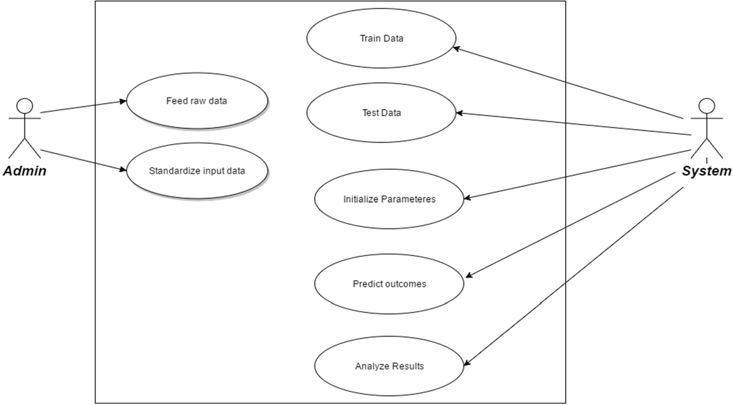

Figure 3.4.1: Use Case Diagram

The use case diagram shows the main functions performed by the admin, as well as the system. Each use case represents a sub-task that is performed to compute the results. The description of the diagram is as follows:
- The admin standardizes the data available from the surveys, to a machine-readable format, so that it can be operated upon using python and its libraries. The data will then be fed to the system for further processing. The system will now divide this data into two data sets – training and testing data.
- Training labels, provided by the user as a part of the standardization, will be used to form a model which will be used for the testing data.
- The system will be initializing parameters for the model based on the training data.

- The testing data will be classified according to the training results and the parameters initialized in the previous step, by the system.
- The system will now classify outcomes, and analyse results to provide viable solutions to the end-users.

11

Chapter 8

Analysis Modeling

Data Modeling

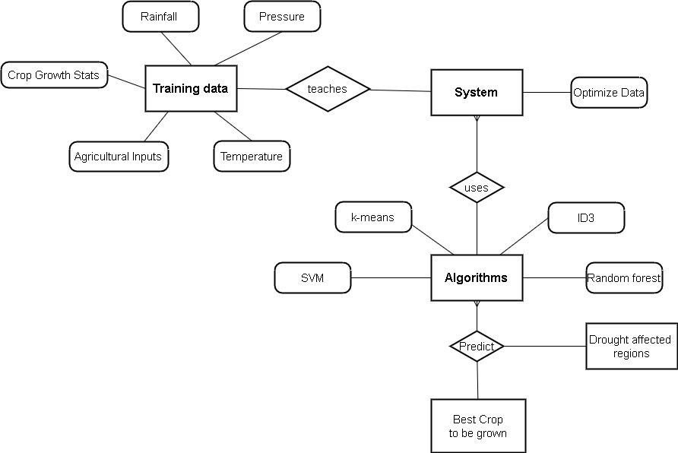
Figure 4.1.1 Data Model (ER Diagram)

An entity relationship model, also called an entity-relationship (ER) diagram, is a graphical representation of entities and their relationships to each other, typically used in computing in regard to the organization of data within databases or information systems. The following diagram represents:
The entities are: Training Data, System, Algorithms. Our first Entity, the training data has attributes as follows:
- Crop growth statistics, which basically gives the total produce of each crop in each district of Tamil Nadu over.
- The amount of agricultural inputs used in the soil. For example, Fertilizers, Pesticides etc.

- Land area which is under cultivation.

12

- Rainfall data over the past 16 years, monthly.

- Temperature data over the past 16 years, monthly.

- Pressure data over the past 16 years, monthly.

The Training data now teaches the system, and the system learns the trends of data. it optimizes the data accordingly.
The System now uses the algorithms to make use of the data to generate final results. Algorithms like:
- K-means

- SVM

- ID3

- Random forest

Which will in turn predict the following:

- Best crop to be grown in a particular area in a particular time period.

- Drought affected regions, and solutions to tackle it.

Activity Diagram/Class Diagram

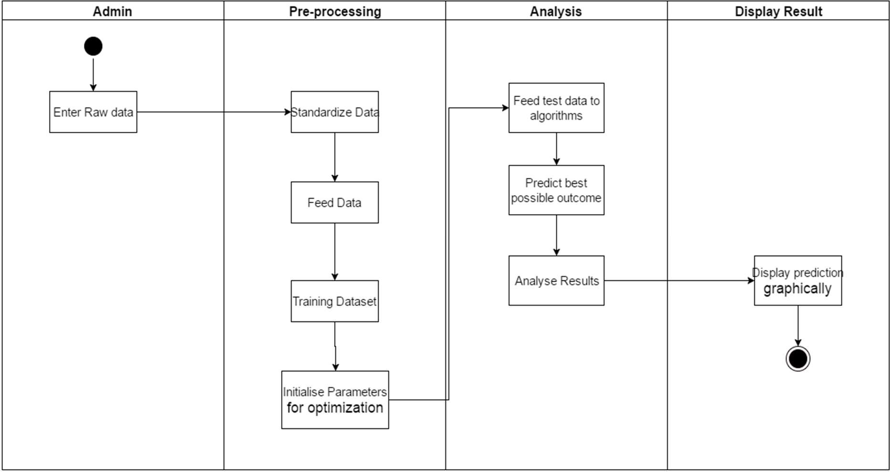

Figure 4.2.1 Swim Lane Activity Diagram

13

The use activity diagram shows chronological order in which steps are followed in a system. Each activity represents a sub-task that is performed serially. The description of the diagram is as follows:
- The admin feeds the raw data obtained from various government website sources. For example: www.mahaagri.gov.in
- After standardizing the input, the admin will feed this raw data to the system as training data.

- Training labels, provided by the user as a part of the standardization, will be used to form a model which will be used for the testing data.
- The system will be initializing parameters for the model based on the training data.

- The testing data will be classified according to the training results and used in the prescribed algorithms.
- The system will now predict outcomes, and analyse results to provide viable solutions to the end-users.
- Finally, a visualization of the data in forms of graphs, pies etc. will be done.

Functional Modeling

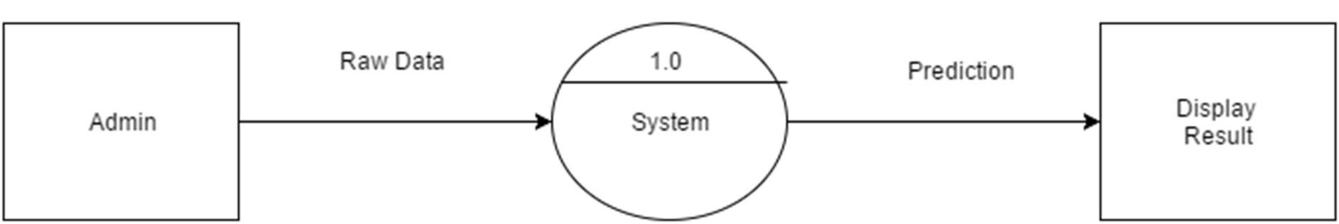

Figure 4.3.1: DFD Level 0

The above diagram is the Level 0 DFD, or the context diagram of the proposed system. It shows the basic inputs that will be fed, and the basic output that is expected from the system. Raw data, standardized by the admin, will be processed upon, and will give us crop suggestions and rainfall predictions.
The Level 1 DFD shows that there is a training phase before the prediction. The standardized data is divided into two datasets – training and testing. The training labels that are provided as a part of the standardization, train the model that will be used for the prediction, and initialize the corresponding parameters. The next component then takes this model and predicts the aforementioned results – crop and rainfall data, which is later displayed by the system.

14

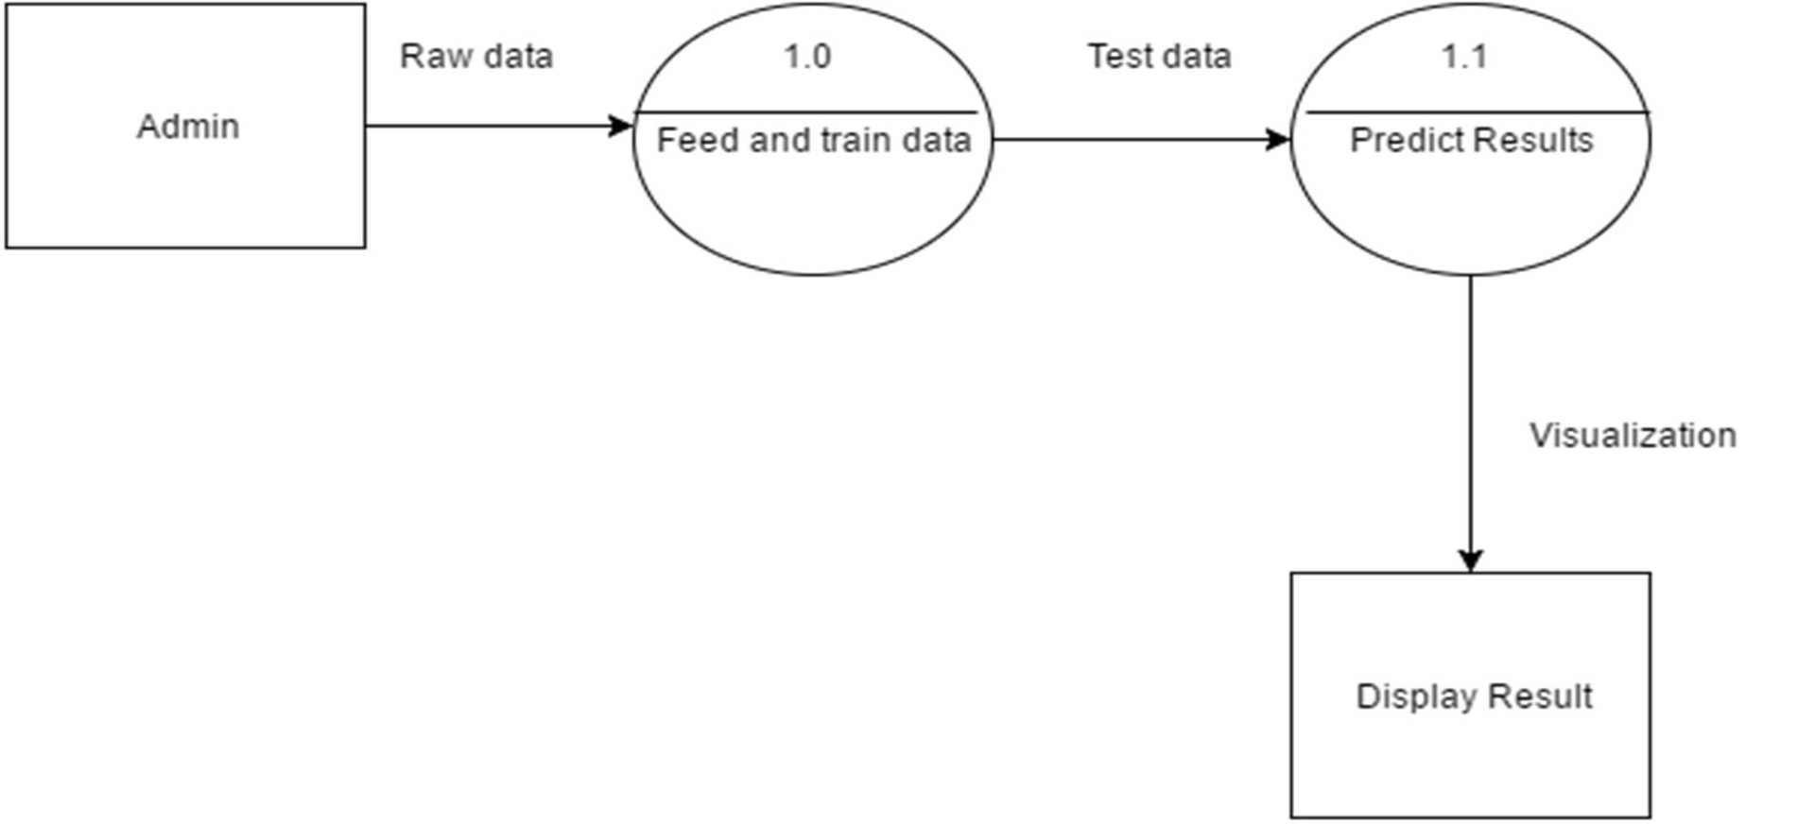

Figure 4.3.2: DFD Level 1

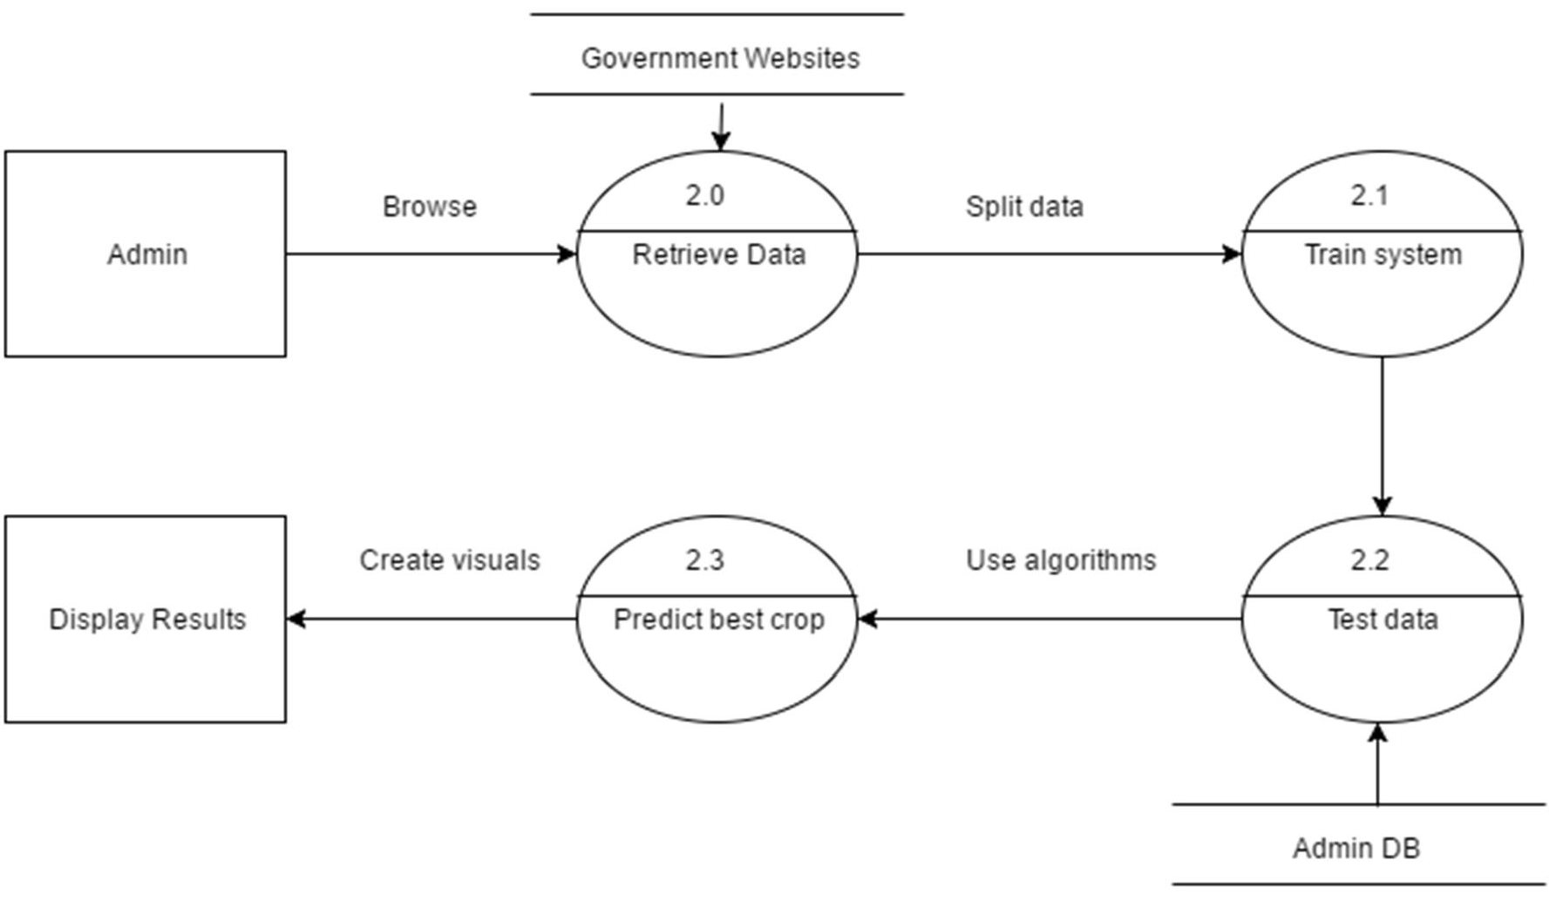

Figure 4.3.3: DFD Level 2

The above diagram, the level 2 DFD, further breaks down the components such that, one component retrieves data from the government websites, which is then standardized by the admin and split into testing and training data. Training data is sent to the training component, which initializes the parameters for testing. Testing data is retrieved from the Admin database, and along with the parameters that were initialized in the previous step, it is passed on to the testing component. The system uses several algorithms to achieve the most optimum crop and rainfall predictions. This is passed on to the visualization component, which displays these

15

relational trends in the form of graphs and charts. These visualizations are then displayed by the display component of the system.

Timeline Chart

The above chart is the graphical depiction of the project schedule, which shows the start and finish dates of several phases – Planning, Modelling and Design, Implementation, Testing and Maintenance, and also shows the corresponding subtasks’ schedule. We estimate that the project will be over by April 2019.
The various tasks included in each phase are:

- Planning: Conducting research pertaining to the project, formulating a problem statement for the project, designing the initial flow of the system and review of literature based on various algorithms and techniques of Data Mining.
- Modeling: Creating of various UML diagrams, gathering data from repositories and forming training data sets based on it.

16

- Implementation: In this phase, we first standardize the data, feed testing data to the system that can run algorithms on it, and generate reports based on the results obtained after execution of algorithms on testing data.
- Testing and Maintenance: This phase is mainly concerned with testing of the system for any errors and eliminating bugs, if any. We generate test cases, test the system and remove the identified bugs, and then the system is improved and maintained.

17

CHAPTER 9
SYSTEM STUDY

FEASIBILITY STUDY

The feasibility of the project is analyzed in this phase and business proposal is put forth with a very general plan for the project and some cost estimates. During system analysis the feasibility study of the proposed system is to be carried out. This is to ensure that the proposed system is not a burden to the company. For feasibility analysis, some understanding of the major requirements for the system is essential.

Three key considerations involved in the feasibility analysis are

- ECONOMICAL FEASIBILITY
- TECHNICAL FEASIBILITY
- SOCIAL FEASIBILITY

ECONOMICAL FEASIBILITY

This study is carried out to check the economic impact that the system will have on the organization. The amount of fund that the company can pour into the research and development of the system is limited. The expenditures must be justified. Thus the developed system as well within the budget and this was achieved because most of the technologies used are freely available. Only the customized products had to be purchased.

TECHNICAL FEASIBILITY

This study is carried out to check the technical feasibility, that is, the technical requirements of the system. Any system developed must not have a high demand on the available technical resources. This will lead to high demands on the available technical resources. This will lead to high demands being placed on the client. The developed system must have a modest requirement, as only minimal or null changes are required for implementing this system.

SOCIAL FEASIBILITY

The aspect of study is to check the level of acceptance of the system by the user. This includes the process of training the user to use the system efficiently. The user must not feel threatened by the system, instead must accept it as a necessity. The level of acceptance by the users solely depends on the methods that are employed to educate the user about the system and to make him familiar with it. His level of confidence must be raised so that he is also able to make some constructive criticism, which is welcomed, as he is the final user of the system.

CHAPTER 10
SOFTWARE ENVIRONMENT
Python:
Python is a high-level, interpreted, interactive and object-oriented scripting language. Python is designed to be highly readable. It uses English keywords frequently where as other languages use punctuation, and it has fewer syntactical constructions than other languages.
- Python is Interpreted − Python is processed at runtime by the interpreter. You do not need to compile your program before executing it. This is similar to PERL and PHP.
- Python is Interactive − You can actually sit at a Python prompt and interact with the interpreter directly to write your programs.
- Python is Object-Oriented − Python supports Object-Oriented style or technique of programming that encapsulates code within objects.
- Python is a Beginner's Language − Python is a great language for the beginner-level programmers and supports the development of a wide range of applications from simple text processing to WWW browsers to games.
History of Python
Python was developed by Guido van Rossum in the late eighties and early nineties at the National Research Institute for Mathematics and Computer Science in the Netherlands.
Python is derived from many other languages, including ABC, Modula-3, C, C++, Algol-68, SmallTalk, and Unix shell and other scripting languages.
Python is copyrighted. Like Perl, Python source code is now available under the GNU General Public License (GPL).
Python is now maintained by a core development team at the institute, although Guido van Rossum still holds a vital role in directing its progress.
Python Features
Python's features include −
- Easy-to-learn − Python has few keywords, simple structure, and a clearly defined syntax. This allows the student to pick up the language quickly.
- Easy-to-read − Python code is more clearly defined and visible to the eyes.
- Easy-to-maintain − Python's source code is fairly easy-to-maintain.
- A broad standard library − Python's bulk of the library is very portable and cross-platform compatible on UNIX, Windows, and Macintosh.
- Interactive Mode − Python has support for an interactive mode which allows interactive testing and debugging of snippets of code.
- Portable − Python can run on a wide variety of hardware platforms and has the same interface on all platforms.
- Extendable − You can add low-level modules to the Python interpreter. These modules enable programmers to add to or customize their tools to be more efficient.
- Databases − Python provides interfaces to all major commercial databases.
- GUI Programming − Python supports GUI applications that can be created and ported to many system calls, libraries and windows systems, such as Windows MFC, Macintosh, and the X Window system of Unix.
- Scalable − Python provides a better structure and support for large programs than shell scripting.
Apart from the above-mentioned features, Python has a big list of good features, few are listed below −
- It supports functional and structured programming methods as well as OOP.
- It can be used as a scripting language or can be compiled to byte-code for building large applications.
- It provides very high-level dynamic data types and supports dynamic type checking.
- It supports automatic garbage collection.
- It can be easily integrated with C, C++, COM, ActiveX, CORBA, and Java.
Python is available on a wide variety of platforms including Linux and Mac OS X. Let's understand how to set up our Python environment.
Getting Python
The most up-to-date and current source code, binaries, documentation, news, etc., is available on the official website of Python https://www.python.org.
Windows Installation
Here are the steps to install Python on Windows machine.
- Open a Web browser and go to https://www.python.org/downloads/.
- Follow the link for the Windows installer python-XYZ.msifile where XYZ is the version you need to install.
- To use this installer python-XYZ.msi, the Windows system must support Microsoft Installer 2.0. Save the installer file to your local machine and then run it to find out if your machine supports MSI.
- Run the downloaded file. This brings up the Python install wizard, which is really easy to use. Just accept the default settings, wait until the install is finished, and you are done.
The Python language has many similarities to Perl, C, and Java. However, there are some definite differences between the languages.

First Python Program
Let us execute programs in different modes of programming.

Interactive Mode Programming
Invoking the interpreter without passing a script file as a parameter brings up the following prompt −
$ python
Python2.4.3(#1,Nov112010,13:34:43)
[GCC 4.1.220080704(RedHat4.1.2-48)] on linux2
Type"help","copyright","credits"or"license"for more information.
>>>
Type the following text at the Python prompt and press the Enter −
>>>print"Hello, Python!"
If you are running new version of Python, then you would need to use print statement with parenthesis as in print ("Hello, Python!");. However in Python version 2.4.3, this produces the following result −
Hello, Python!

Script Mode Programming
Invoking the interpreter with a script parameter begins execution of the script and continues until the script is finished. When the script is finished, the interpreter is no longer active.
Let us write a simple Python program in a script. Python files have extension .py. Type the following source code in a test.py file −
print"Hello, Python!"
We assume that you have Python interpreter set in PATH variable. Now, try to run this program as follows −
$ python test.py
This produces the following result −
Hello, Python!

Flask Framework:
Flask is a web application framework written in Python. Armin Ronacher, who leads an international group of Python enthusiasts named Pocco, develops it. Flask is based on Werkzeug WSGI toolkit and Jinja2 template engine. Both are Pocco projects.
Http protocol is the foundation of data communication in world wide web. Different methods of data retrieval from specified URL are defined in this protocol.
The following table summarizes different http methods −
Sr.No | Methods & Description
1 | GET  Sends data in unencrypted form to the server. Most common method.
2 | HEAD  Same as GET, but without response body
3 | POST  Used to send HTML form data to server. Data received by POST method is not cached by server.
4 | PUT  Replaces all current representations of the target resource with the uploaded content.
5 | DELETE  Removes all current representations of the target resource given by a URL
By default, the Flask route responds to the GET requests. However, this preference can be altered by providing methods argument to route() decorator.
In order to demonstrate the use of POST method in URL routing, first let us create an HTML form and use the POST method to send form data to a URL.
Save the following script as login.html
<html>
<body>
<formaction="http://localhost:5000/login"method="post">
<p>Enter Name:</p>
<p><inputtype="text"name="nm"/></p>
<p><inputtype="submit"value="submit"/></p>
</form>
</body>
</html>
Now enter the following script in Python shell.
from flask importFlask, redirect,url_for, request
app=Flask(__name__)
@app.route('/success/<name>')
def success(name):
return'welcome %s'% name
@app.route('/login',methods=['POST','GET'])
def login():
ifrequest.method=='POST':
user=request.form['nm']
return redirect(url_for('success',name= user))
else:
user=request.args.get('nm')
return redirect(url_for('success',name= user))
if __name__ =='__main__':
app.run(debug =True)
After the development server starts running, open login.html in the browser, enter name in the text field and click Submit.
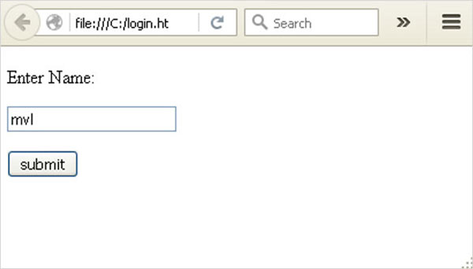
Form data is POSTed to the URL in action clause of form tag.
http://localhost/login is mapped to the login() function. Since the server has received data by POST method, value of ‘nm’ parameter obtained from the form data is obtained by −
user = request.form['nm']
It is passed to ‘/success’ URL as variable part. The browser displays a welcome message in the window.
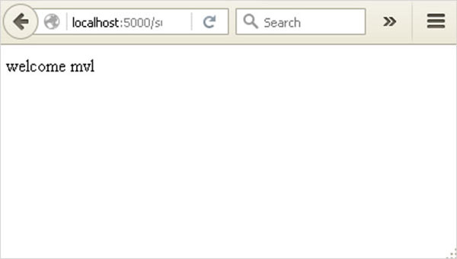
Change the method parameter to ‘GET’ in login.html and open it again in the browser. The data received on server is by the GET method. The value of ‘nm’ parameter is now obtained by −
User = request.args.get(‘nm’)
Here, args is dictionary object containing a list of pairs of form parameter and its corresponding value. The value corresponding to ‘nm’ parameter is passed on to ‘/success’ URL as before.

What is Python?
Python is a popular programming language. It was created in 1991 by Guido van Rossum.
It is used for:
- web development (server-side),
- software development,
- mathematics,
- system scripting.
What can Python do?
- Python can be used on a server to create web applications.
- Python can be used alongside software to create workflows.
- Python can connect to database systems. It can also read and modify files.
- Python can be used to handle big data and perform complex mathematics.
- Python can be used for rapid prototyping, or for production-ready software development.
Why Python?
- Python works on different platforms (Windows, Mac, Linux, Raspberry Pi, etc).
- Python has a simple syntax similar to the English language.
- Python has syntax that allows developers to write programs with fewer lines than some other programming languages.
- Python runs on an interpreter system, meaning that code can be executed as soon as it is written. This means that prototyping can be very quick.
- Python can be treated in a procedural way, an object-orientated way or a functional way.
Good to know
- The most recent major version of Python is Python 3, which we shall be using in this tutorial. However, Python 2, although not being updated with anything other than security updates, is still quite popular.
- In this tutorial Python will be written in a text editor. It is possible to write Python in an Integrated Development Environment, such as Thonny, Pycharm, Netbeans or Eclipse which are particularly useful when managing larger collections of Python files.
Python Syntax compared to other programming languages
- Python was designed to for readability, and has some similarities to the English language with influence from mathematics.
- Python uses new lines to complete a command, as opposed to other programming languages which often use semicolons or parentheses.
- Python relies on indentation, using whitespace, to define scope; such as the scope of loops, functions and classes. Other programming languages often use curly-brackets for this purpose.

Python Install
Many PCs and Macs will have python already installed.
To check if you have python installed on a Windows PC, search in the start bar for Python or run the following on the Command Line (cmd.exe):
C:\Users\Your Name>python --version
To check if you have python installed on a Linux or Mac, then on linux open the command line or on Mac open the Terminal and type:
python --version
If you find that you do not have python installed on your computer, then you can download it for free from the following website: https://www.python.org/

Python Quickstart
Python is an interpreted programming language, this means that as a developer you write Python (.py) files in a text editor and then put those files into the python interpreter to be executed.
The way to run a python file is like this on the command line:
C:\Users\Your Name>python helloworld.py
Where "helloworld.py" is the name of your python file.
Let's write our first Python file, called helloworld.py, which can be done in any text editor.
helloworld.py
print("Hello, World!")
Simple as that. Save your file. Open your command line, navigate to the directory where you saved your file, and run:
C:\Users\Your Name>python helloworld.py
The output should read:
Hello, World!
Congratulations, you have written and executed your first Python program.

The Python Command Line
To test a short amount of code in python sometimes it is quickest and easiest not to write the code in a file. This is made possible because Python can be run as a command line itself.
Type the following on the Windows, Mac or Linux command line:
C:\Users\Your Name>python
From there you can write any python, including our hello world example from earlier in the tutorial:
C:\Users\Your Name>python
Python 3.6.4 (v3.6.4:d48eceb, Dec 19 2017, 06:04:45) [MSC v.1900 32 bit (Intel)] on win32
Type "help", "copyright", "credits" or "license" for more information.
>>> print("Hello, World!")
Which will write "Hello, World!" in the command line:
C:\Users\Your Name>python
Python 3.6.4 (v3.6.4:d48eceb, Dec 19 2017, 06:04:45) [MSC v.1900 32 bit (Intel)] on win32
Type "help", "copyright", "credits" or "license" for more information.
>>> print("Hello, World!")
Hello, World!
Whenever you are done in the python command line, you can simply type the following to quit the python command line interface:
exit()
Execute Python Syntax
As we learned in the previous page, Python syntax can be executed by writing directly in the Command Line:
>>> print("Hello, World!")
Hello, World!
Or by creating a python file on the server, using the .py file extension, and running it in the Command Line:
C:\Users\Your Name>python myfile.py

Python Indentations
Where in other programming languages the indentation in code is for readability only, in Python the indentation is very important.
Python uses indentation to indicate a block of code.
Example
if 5 > 2:
print("Five is greater than two!")
Python will give you an error if you skip the indentation:
Example
if 5 > 2:
print("Five is greater than two!")

Comments
Python has commenting capability for the purpose of in-code documentation.
Comments start with a #, and Python will render the rest of the line as a comment:
Example
Comments in Python:
#This is a comment.
print("Hello, World!")
Docstrings
Python also has extended documentation capability, called docstrings.
Docstrings can be one line, or multiline.
Python uses triple quotes at the beginning and end of the docstring:
Example
Docstrings are also comments:
"""This is a
multiline docstring."""
print("Hello, World!")

CHAPTER 11

CONCLUSION AND FUTURE ENHANCEMENT

  - CONCLUSION
This thesis focuses on analyzing the agricultural soil data using data mining for crop yield prediction. In this paper, we've got suggested an analysis of the soil information using completely different algorithms and prediction technique. In this paper we have demonstrated comparative study of varied regression algorithms. The system does not allow any abnormal circumstances to affect the production rate. It efficiently manages the energy and human resources. Distant control mechanism used in the system improves the efficiency by reducing the effort required by the farmer to monitor and act according to the changes in the field. Wireless monitoring along with low power consumption makes it a useful system for the farmer to incorporate and use it in the agricultural farm. The goals that have been achieved by the developed system are:
    - Simplified and reduced the manual work.
    - Large volumes of data can be stored.
- It provides Smooth workflow.
In case we wish to yield particular crop, then we can improve the soil by adding the necessary nutrients in the soil as per required by that crop.

FUTURE ENHANCEMENT
In future, we can plan to build Fertilizer Recommendation System which can be utilized effectively by the Soil Testing Laboratories. This System will recommend appropriate fertilizer for the given soil sample and cropping pattern. We can add module if any queries are there, the staff can directly interact with the administrator very easily. We can also determine the efficient algorithm based on their accuracy metrics that will helps to choose an efficient algorithm for crop yield prediction.

REFERENCE
[1] Tianjun Wu , Jiancheng Luo, Wen Dong, Yingwei Sun , Liegang Xia , and Xuejian Zhang, Geo-Object-Based Soil Organic Matter Mapping Using Machine Learning Algorithms With Multi-Source Geo-Spatial Data, IEEE Journal Of Selected Topics In Applied Earth Observations And Remote Sensing, 2019
.N.ANANTHI Divya J. Divya M. Janani V, IoT based Smart Soil Monitoring System for Agricultural Production, IEEE International Conference On Technological inovations in ICT for Agriculture and Rural development (TIAR_2017)

[3] Jyothi patil Dr A.Govardhan Dr V.D.Mytri, An Intelligent System for Predicting Thrips Tabaci Linde Pest Population Dynamics Allied To Cotton Crop,

[4] Nidhi H Kulkarni Dr. G N Srinivasan Dr. B M Sagar Dr.N K Cauvery, Improving Crop, Productivity Through A Crop Recommendation System Using Ensembling Technique, IEEE International Conference on Computational Systems and Information Technology for Sustainable Solutions(2018)

[5] P. S. Asolkar Prof.Dr. U. S. Bhadade, An Effective Method of Controlling the Greenhouse and Crop Monitoring Using GSM,(2015)

[6] Md. Tahmid Shakoor, Karishma Rahman, Sumaiya Nasrin Rayta, Amitabha Chakrabarty, Agricultural Production Output Prediction Using Supervised Machine Learning Techniques,(2017)

[7] Zhang Miao1, 2, Li Qiangzi1 , Wu Bingfang1,*, Investigating the capability of multi- temporal Landsat images for crop identification in high farmland fragmentation regions,

[8] D. Turgay AltılarAnıl Suat Terliksiz, Comparison of Statistical Methods for Predicting Wheat Yield Trends in Turkey,

[9] Sanat Sarangi, Somya Sharma, Bhushan Jagyasi, Agricultural Activity Recognition with Smart-shirt and Crop Protocol, Global Humanitarian Technology Conference(2015)

[10] Luminto a. Harlili, M, Weather Analysis to Predict Rice Cultivation Time Using Multiple
Linear Regression to Escalate Farmer’s Exchange Rate,

[11] Bert LittleMichael SchuckingKenton Ross, High Granularity Remote Sensing and Crop Production over Space and Time: NDVI over the Growing Season and Prediction of Cotton Yields at the Farm Field Level in Texas, IEEE International Conference on Data Mining Workshops, (2008)

